Long Waves: An Update
Tsang Shu-ki (www.sktsang.com)
30 July 2003

The spectre of long waves

Soviet economist Nikolai Kondratieff (1892-1938) proposed the theory of capitalist long waves in the 1920s. His major evidence included prices (wages, interest rates), trade volumes and deposits. Since 1970's, interest on the theory has been revived, with lingering and unsettled debates on whether there would be a recurrence of a depression of the 1930's type.

Now, with the bursting or the “new economy” bubble and the shadow of deflation gathering in the US, the theory is getting more attention again. I wrote the piece “Kondratieff Long Waves Unsynchronized---KLUWs--- at Last?” (http://www.hkbu.edu.hk/~sktsang/Lwsal.pdf) in April 2001. Now two years later, the Japanese economy is still finding the bottom, while nothing exciting has occurred in Europe. In response to the unprecedented series of 13 cuts in interesting rates, the US financial and housing markets have shown periodic exuberance. But a firm trajectory of recovery is still elusive. Has the downwave finally arrived?

The long cycles of prices

Figure 1, based on the historical statistics of Robert Sahr (oregonstate.edu/Dept/pol_sci/fac/sahr/sahr.htm), shows the long cycles of prices in the last three and half centuries. As can be seen, prices before the 20th century went up and down in protracted swings, but they were within bounds on both sides, except the upwave that we are now facing. The surge after the 2nd World War has been astonishing by historical standards. So will be any downward adjustment that may indeed emerge?

Figure 1
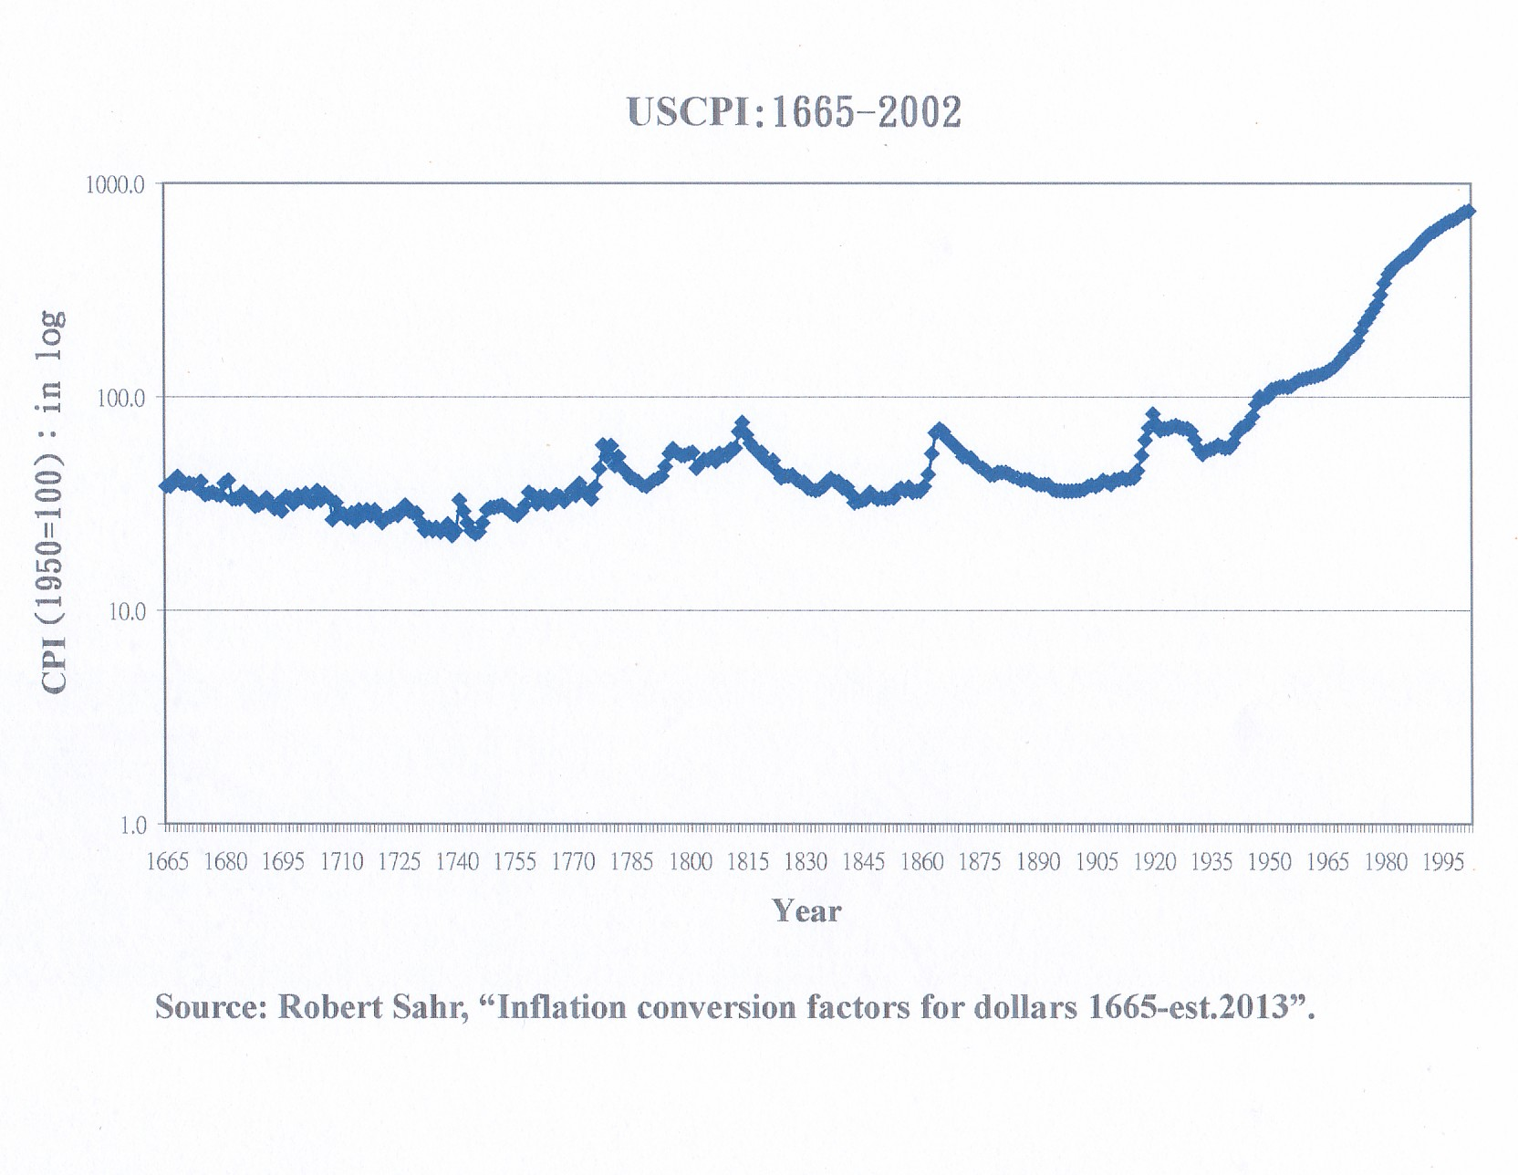

Four factors behind long waves

Why does the capitalist economic system generate long waves? In 1988, I wrote an article (www.sktsang.com/ArchiveIII/Tsang_1088.pdf) for the Tokyo Club Foundation for Global Studies, in which I listed four major factors behind the long waves:

(1) Over-investment: In the upwave, optimistic expectations bring about massive investments. Because of the self-ordering effect in the capital goods sector, a reinforcing spiral is formed, leading to over-capacity.

(2) Under-consumption: Income and wealth distribution tilts towards the capitalist class and against the middle and lower strata of the society. Disparity dampens aggregate purchasing power, resulting in a “realisation crisis” for paper profits.

(3) Demographic cycles: Because of political or social factors (e.g. the end of a war), “baby boom” leads to a rapid growth in population and eventually provides sufficient labour supply and market demand. But hedonism, materialism and other cultural changes follow; birth rates plunge; and the whole process is reversed.

(4) Technological cycles: Investments pour into the “new” economic sector, which later turns outmoded. Anyway, parties of vested interests resist even “newer” technologies, forming a “technological stalemate”. Production efficiency slips, resulting in a vicious supply-demand circle.

These four factors interact and reinforce each other. Investments in traditional technologies generate excess supplies of goods and services, which unwittingly face under-consumption due to uneven distribution and slowing population trends. These nurture the downwave. However, around the turning point, financial euphoria about rosy scenarios arising from the “new economy” typically takes the centre stage, testifying the quagmire of “too much money chasing too few profitable opportunities”.

“Indulging” financial system

Nevertheless, why has the upwave that we are facing been so extraordinary? From Figure 1, it can be seen that prices were relatively stable in the 18th and 19th centuries. Even at the peak of the last long wave (1920), US CPI was only 270% above the low of the 18th century (1739). But the index in 2002 was 799.5% more than that of 1920! Take an example of a good such as chocolate. According to Bill Fleckenstein, an ounce of Hershey’s (which was launched at the beginning of the 20th century) is now 12 times more expensive. Ceteris paribus, the purchasing power the US dollar has plunged by over 90%. (Note 1)

The crux of the problem is, as said, “too much money chasing too few profitable opportunities”. In the past few decades, unfortunately, the amount of money created was more than too much. Two of new developments have been: (1) the rapid growth of banking and financial institutions based on fractional reserves and leveraging, which results in the phenomenal expansion of the money supply, liquidity and debt; and (2) the instability of the international financial order after the collapse of the Dollar Standard under which the greenback was convertible into gold.

The ballooning of debt in the US is revealed in Figure 2. It seemed to have stabilised in the 1990s, thanks to the improvement in public finances. But the tax reduction programme of Bush Jr., along with the ageing of the “baby boomers”, are threatening to push the government into the muck again. (The latest estimate by the White House is that the budget deficit this year would reach US$455 billion, far exceeding the previous record of US$290 billion in 1992). Following the bursting of the stock market bubble, investment by enterprises has remained anemic, while consumers who float near zero savings have become the engine of the economy. If we look at the ratio of total credit market debt to GDP, like Charles Minter and Martin Weiner did, the situation is even worse. (Note 2) It peaked at 270% during the Great Depression. Debt destruction subsequently pushed the ratio down to about 110%. However, it climbed again in the 1980s, and reaches 300% now.

Figure 2

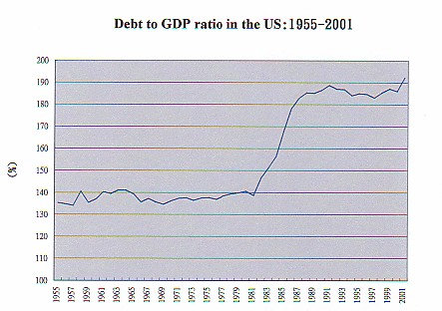

Source: International Financial Statistics, IMF.

Commentators like Frank Shostak, Martin Hutchinson and William Wolman have openly questioned the policies and tactics of Alan Greenspan, who has been at the helm of the US Fed since August 1987. Driven by the myth of the “new economy”, the NASDEQ bubble was the craziest collective gambling in human history. At the height of its folly, the NASDAQ was valued at 245 times of its earnings. And the market capitalisation of Priceline exceeded the total of the major US airlines (Delta, US Airways, United, Northwest, Southwest and American)!

In December 1996, while the Dow was still at the level of 6000, Greenspan warned about “irrational exuberance” in the market. However, he turned a follower of the “new economy” himself afterwards, and openly endorsed the “productivity miracle” in the US. (Note 3) The market crashed in 2000; and the economy headed south. Greenspan then resorted to incessant interest rate cuts in an effort to buttress it. Since January 2001, 13 cuts have been engineered, bringing the rates to their 45-year lows. But the major consequence was another bubble in the housing market. This has angered many analysts, including Bill Fleckenstein, who temperamentally called the Fed led by Greenspan “the most incompetent and irresponsible …. in history”, and considered it “Public Enemy No. 1”. (Note 4)

An international financial order that “lacks discipline”

In the international arena, the Dollar Standard turned out to be unsustainable and was abandoned in the early 1970s. However, the international financial system failed to stabilise. The world has witnessed wave after wave of problems, starting with the Third World Debt Crisis of the 1980s. After the East Asian Financial Turmoil, talks of reforms in international financial architecture abounded, but no serious measures eventuated. In the meantime, the US’s current account deficit has continued to widen, registering the record of 4.8% of GDP in 2002. The country has become the biggest debtor in the world, borrowing from the latter US$1.5 billion every day.

This has resulted in a vast increase in international reserves, as shown in Figure 3. Before the 1970s, reserves grew very slowly. Consisting mainly of US dollars, they jumped from that time onwards, by 700% within two decades. As the key medium of exchange in international trade, central banks around the world have had little choice but to accumulate US assets by investing in the country’s financial markets. In the 33 years since 1969, global reserves rose by a stunning multiple of 23!

Figure 3
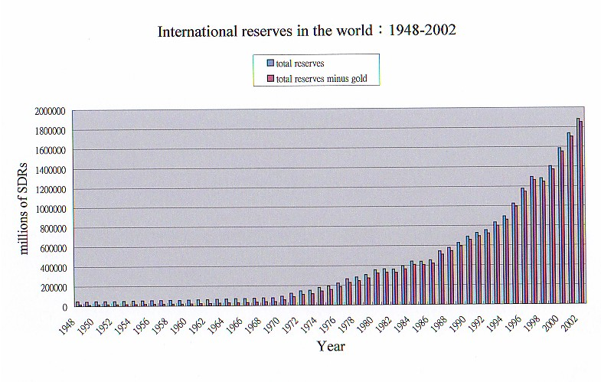

Source: International Financial Statistics, IMF.

Of course, this does not imply that a metallic standard (based on gold, silver, or an indirect link via the US dollar) is necessarily superior, although quite a number of conservative economists (including those in the Austrian School) have argued for a return to the classical system. The failure of the gold standard was precisely a result of its inflexibility. Alternative proposals, like the tripartite system of the US dollar, the yen and the euro could be investigated (a similar one with the Deutsche mark as the third currency was actually quite popular in the 1970s). Nevertheless, it is difficult to vindicate the present international financial order dictated by the US dollar.

Muddle though, deflationary or inflationary depression?

Looking ahead, adjustments are likely to persist, especially as the build-up in debt has not stopped, not to mention gone into cleansing. After inflation, deflation seems natural. Economists like Paul Krugman have stressed the possibility of the US economy being caught in the liquidity trap. Further reductions in interest rates (even to zero) would only bring short-run excitement to the market, but not significant and lasting real effects. (Note 5) In other words, deflationary depression would become the only way of curing the disease and restoring order to the economy. The question is: How serious would the situation be? 25% as serious as Japan’s? One half? Or 75%?

If the Fed tries really hard and uses all the “unconventional methods”, which Alan Greenspan said he would not rule out in his July 2003 testimony at the Congress, the US economy might be able to “muddle through” for the time being (25% - 50% of Japan?). (Note 6) However, that could mean there would be more piling up of contradictions and “misallocation of capital”. The eventual reckoning might be even more painful.

This is what another school, a more pessimistic one, is focusing on. Its followers argue that irresponsibility and the lack of discipline undermined the core of the financial system during the past decades, and procrastination has done almost irreparable damages. A full-fledged currency crisis, essentially that of the US dollar, has been in the making. This view is shared to various extents, amongst others, by analysts like Richard Duncan, Bill Fleckenstein, and the “gold bulls”. Comments by top Fed officials like Ben Bernanke and Roger Ferguson concerning the use of the printing press and the purchase of government bonds to provide liquidity in a fight against deflation have been severely criticised by some of them, who predict that the mess would result in inflationary depression. The recent sharp fall in bond prices may partly be a warning against the record levels of current account and budget deficits (while the optimists certainly like to see it as a sign of a “solid recovery”).

A pitiful calamity such as an inflationary depression occurred in quite a number of developing countries (including China in the 1930s), and would add a new dimension to the long waves (the dollar did not go off the cliff during the Great Depression). But if it takes place in the leading economy of the world, which accounts for 1/3 of its GDP and has provided 2/3 of its recent growth momentum, the consequences could be dire.

In comparison, the probability of inflationary depression in the US should still be smaller than that of deflationary depression. A scenario of a vicious circle of a plunging greenback and deteriorating inflation would render the Fed a more incompetent lot than the central bank and the treasury in Japan. The economic fundamentals in the US, as yet, are less messy than those in the latter. (Note 7)

Whether it be deflationary depression or inflationary depression, I hope that prospect could be avoided. But as Krugman said, a hope is not a plan. Kondratieff should no doubt agree, somewhere in paradise.

Notes

(1) “The dollar is on borrowed time”, Contrarian Chronicles, 5 May 2003 (moneycentral.msn.com/content/P46779.asp).

- “The bubble, deflation, and implications for real estate”, Comstock Partners Inc (www.comstockfunds.com/html/TheBubble.htm).

- For a more objective analysis of the computer revolution and the implications for productivity growth in the US, see Robert Gordon, “High-tech Innovation and Productivity Growth: Does Supply Create Its Own Demand?” (http://faculty-web.at.nwu.edu/economics/gordon/NBERPaper.pdf)

- Same as (1) 。

- Paul Krugman, “Zero is not enough”, 4 May 2003 (www.wws.princeton.edu/~pkrugman/zero.html).

- See, for example, John Mauldin, “Mid-2003 Forecast: Muddle Through” (http://www.safehaven.com/Editorials/mauldin/070503.htm).

- Martin Hutchinson threw some doubts on this point in his “Happy days NOT here again” (www.upi.com/view.cfm?StoryID=20030616-054440-5716r).

