Fiscal deficit, bonds and currency board

Tsang Shu-ki (3/3/2003)

Back in 2001, I made the point in an advisory committee of the SAR government that it should issue bonds to tackle the emerging fiscal problems. Issuing bonds was consistent with inter-generational equity in resource allocation: this generation could get interest yields from buying bonds; and the next generation, the major beneficiaries of bonds-financed projects, would pay taxes to retire those bonds in return. Practically, it would give the SAR government more time to handle the structural deficit. There was no need, and it would not be justifiable, to put the sole burden on this generation by running down the cumulative fiscal reserves hard earned by it and indeed past generations.

Nothing eventuated. It was not a surprise to me.

In September 2002, other than reiterating the point of equity, I wrote the following in an email to a researcher who questioned me about the consistency between bond issuance and the currency board system.

“Dear XXX,

………………….

As to the technical point, a currency board has to stick to one basic principle: it must have at least 100% foreign exchange reserve cover for the monetary base. The monetary base refers to either notes and coins in the classical case or all the liabilities of the currency board/central bank in the modern case (e.g. the AEL model). It is with the base that the banking system creates broad money through the multiplier effect. As long as the issuance of government bonds does not breach this principle, it is, as far as I understand, OK.

In fact, the East European CBs (Estonia, Lithuania, Bulgaria) all have outstanding government debts/bonds, not to mention Argentina (which had too much of them, one of the reasons for the collapse of its CB system). If the government issues bonds in foreign currency (USD in the case of HK or euro in the EU case), it will be equivalent to a BOP surplus and the government automatically gets the foreign exchange reserve. If it issues debts in the domestic currency, as long as they are purchased by the private sector, they become "inside money", going from one pocket to another, i.e. the money “washes out” and there will be no expansionary effect.

However, if the debts are purchased by the central bank, which then produces new notes and coins; or if the banking sector buys them, and places them with the central bank as reserve balances (which is equivalent to the central bank buying bonds from the government via banks), the monetary base will be enlarged WITHOUT a correspondent increase in foreign exchange reserves, and a basic currency board principle is violated because it is “the monetisation of government deficits”.

What you said is right. Even given a hard peg like a CBA, domestic interest rates could diverge from (be higher or lower than) those of the anchor currency. In 2000, short rates in HK were for quite some time below those of the USD. Now of course, there are persistent forward premiums. The divergence could be caused by fiscal or other factors.

I've lumped them together and call them the "systemic risk", as distinguished from the "efficiency risk" inherent in the specific designs of the CBA. A deteriorating fiscal position would of course heighten systemic risk and investors would ask for higher interest rates.

……………..”

In short, carefully handled, the issuance of bonds is consistent with the principle of inter-generational equity in resource allocation; and would not violate the disciplinary requirements of a currency board regime.

Addendum (5/3/03)

In his Budget presented today, the Financial Secretary Mr. Antony Leung put forth the following arguments against issuing bonds for now:

“107. Some have suggested that the Government should issue bonds, and employ financial management techniques to generate revenue which could be classified as income under our cash-based accounting system, so as to avoid substantially raising tax and cutting expenditure. The Government is not totally against issuing bonds. The questions that have to be considered are the use of the funds so raised, and the interest costs so incurred.

108. Infrastructure is an investment in the future. If there is a lack of funds, the issuance of bonds is an acceptable option. The Government has issued bonds on three occasions in the past. The Financial Secretaries of the day clearly indicated that the purpose of issuing bonds was to provide funding for capital works projects. However, the problem before us now is that our Operating Account suffers from a prolonged shortage of revenue to cover expenditure. Issuance of bonds can only meet cashflow requirements but cannot solve the underlying problem. For the time being, we can draw on our fiscal reserves to cope with the deficit, and the cost of issuing bonds is higher than the investment income from the fiscal reserves. Therefore, we do not see any need to issue bonds.”

I am happy that the government is not “totally against issuing bonds” and Mr. Leung cited past examples. The arguments so put forward are however not convincing. First, issuing bonds to finance operating deficit with no long-term benefit is generally regarded as unwise---this is just common sense. But the alternative---drawing down fiscal reserves also adversely affects future recurrent investment incomes because the reserve base would become smaller. So the whole issue goes back to the relative rates between the cost of financing bonds and the returns on the fiscal reserves, as stated in paragraph 108. If the former is higher than the latter, the government would pay more than it could earn (e.g. through the Exchange Fund).
The twist is that it depends on what rates one is looking at. Presently, 10-year US Treasury Bonds are traded at the implied rate of about 3.6%, while 10-year Exchange Fund Paper has a yield of about 4.5%. On the other hand, the compounded annual rate of the returns of the Exchange Fund was 6.3% in 1994-2002, and 5.3% in the four years ending 2002. In other words, based on historical figures, the cost of financing bonds should be lower, and not higher, than the rate of returns in reserves investment (unless the Financial Secretary has information or assessment that he has not revealed to the public).
Of course, looking into the future, things may become uncertain, although the Budget assumes that the EF return rate will be 4.5% in 2003-04, and 5% in the following four years. But after the unprecedented series of 13 cuts in US interest rates, how low can one expect bond rates to fall to? Are we missing an uncommon chance? And if we are pessimistic about the future returns of the Exchange Fund, we will be locked into an ironical situation. Suppose the returns fall to zero (not unimaginable, given the bad investment climate, and just in the year of 2001, it was only 0.7%), we should NEVER issue any bonds and should just let the reserves fall, whatever the situation?
Another important issue is of course that if the fiscal reserves continue to fall, the risk premium that investors will demand in any sale of government bonds may rise, increasing its cost. Is the government so confident that this will not happen?
Moreover, because of the shortfall in land revenue after the nine measures of November 2002, the government is actually worried about the capital account as well: that is why Mr. Leung projects the sale and securitisation of public assets to the tune of HK$112 billion in the next five years. What are the comparative merits and cost-benefit of one-off privatisation versus selling bonds? This is a serious issue. Unfortunately, we are not given any analysis in the Budget.
Finally, the distinction between the operating account and the capital account is not that clear-cut. For example, if the government adopts preferential tax policies on some industries and services that are regarded as engines of growth for Hong Kong, together with assistance in providing low-interest working capital, its operating revenue may fall and/or its operating deficit may increase in the short run. But this is a form of long-term investment. If these industries can lead Hong Kong out of the economic doldrums, operating revenue will rise in the future, narrowing or even closing the operating deficit.
A lot is at stake. More serious analysis and discussions are called for.

Postscript
Tsang Shu-ki (25/3/2003)

The crux of the problems

Hong Kong’s fiscal difficulties now seem to have become the focus of the government’s attentions, absorbing all its energy. Long-term strategies have been forgotten or shelved. This “short-termism” is a very dangerous tendency.

Facing the budgetary gap, the gut reaction of the government is to cut expenditure and raise revenue. However, ultimately, everything depends on growth. The core problem with the local economy is the sputtering growth engine, which was thrown into disarray as a result of the transition syndrome and the pre-1997 bubble, as well as the rapidly rising challenges of city and regional economies in the Mainland such as Shanghai, Shenzhen and the rest of the Pearl River Delta. According to research reports of the HKMA, Hong Kong’s potential GDP growth fell from 8% in the early 1980s to 3.5%-4.0% in 1998-2000 (while that of our competitors like South Korea, Taiwan and Singapore were in the range of 4%-6%). And the natural rate of unemployment rose from 2%-3% to 3%-4% in the 1990’s. (Note)

In the past two years, the economy has fallen into doldrums, with a lack of clear direction. It is conceivable that the potential GDP growth rate might be further drifting downwards. This would certainly affect fiscal revenue buoyancy. Since various kinds of expenditure (e.g. civil service pays) show nominal rigidity, the budgetary gap is bound to deteriorate.

In any case, a simple-minded attempt to cut expenditure and raise revenue in a time of structural and cyclical problems could easily backfire, leading to a downward spiral, unless it enhances efficiency, which is much easier said than done. The key is for the Hong Kong economy to transit to a new growth trajectory.

Structural fiscal deficits could be “good” or “bad” in nature. Good examples include the present one in Mainland China, and the imbalance during the era of Reagan’s tax cuts, which helps (helped) structural upgrading and reforms in the economy. The most notorious bad example is that of Japan. Nevertheless, the problems there have not just been fiscal, but have arisen from a series of policy mistakes and as a result of resistance by parties of vested interests towards reforms. If it is not handled carefully, the SAR runs the danger of repeating that experience, albeit in a different style.

Deficits serious but the SAR government still has a lot of reserves

The government has apparently adopted the method of crisis management in handling the budget deficit. In fact, this method might boomerang if it generates a misconceived mood of pessimism about the economic future. In fact, very few governments in the world now have cumulative fiscal reserves (other than Singapore, Borneo, Norway). The HK$300 billion of “fiscal reserves” now in the SAR government’s coffers is equivalent to 15 months of expenditure. According to the forecast in the latest Budget, it would go down to 9 months in the years ahead. Which would still be higher than the average of 6 months in the 1980s.

Moreover, the actual fiscal reserves are more than HK$300 billion, because the accumulated surplus of the Exchange Fund is partly attributable to past investment returns of the reserves. The Financial Secretary has the power to transfer the money into the government’s budget.

Basically, the Exchange Fund of over HK$900 billion can be divided into three roughly equal components:
- Fiscal reserves: about HK$300 billion;
- Backing Portfolio of the Currency Board Account: about HK$300 billion (covering 105%-112.5% of the monetary base);
- Accumulated surplus: more than HK$300 billion.

Such financial prowess is rare in the world. Of course, a fiscal deficit of over 5% of GDP is a serious problem, and the future does not presage optimism. Nevertheless, the Government should not use the fear tactic, which might unwittingly create a sense of panic and divide (instead of unify) the public. What is important is to use the remaining financial resources and coordinate the efforts of various sectors to open up new grounds for the economy and to bring the economy to a robust trajectory of growth. Without the latter, it is very difficult to balance the budget.

The government bonds backing portfolio

In issuing bonds, the Government can consider the setting up of a backing portfolio, with assets allocated from the accumulated surplus of the Exchange Fund or the receipts of bonds (if denominated in foreign currencies), just like the way the monetary base is backed. This would enhance the confidence of investors, and if it is deemed appropriate, the Government could indicate to the public that the linked exchange rate would not be changed before the maturity of the bonds.

Bonds versus privatisation

Theoretically, if government assets could fetch good prices, and their transfer into private hands could enhance efficiency and improve product/service standards, they might be privatised. But in an environment of fuzzy economic prospects, low inflation (or even deflation) and low interest rates, it is difficult to achieve these objectives. If the assets are sold at low prices, the government would be criticised later, when prices pick up and the cycle turns, for selling off the “crown jewelry” at unnecessarily deep discounts. On the other hand, issuing bonds at low interest rates would be regarded as an act of wisdom!

In general, the optimal timing of bond issuance versus privatisation can be presented as in the following diagram:

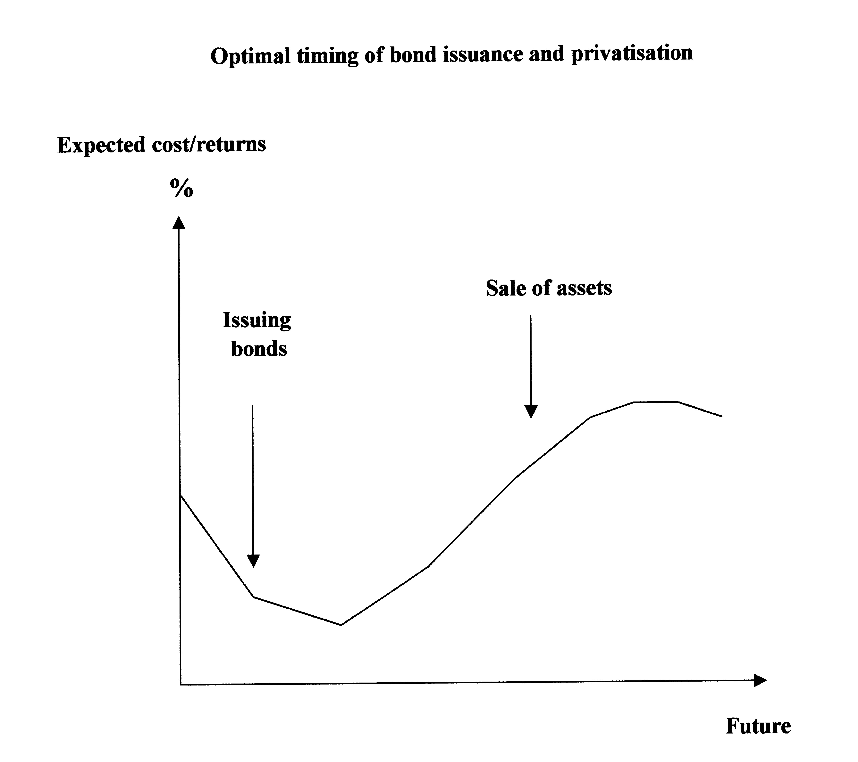
From this angle, these two choices are not mutually exclusive. But given the foreseeable economic climate, while assuming no perfect foresight, bonds should be given priority.

The establishment of the Economic Development Board

All in all, the key to balance the budget in a far-sighted way is to facilitate the emergence of new growth momentum in the Hong Kong economy. In this regard, the SAR Government must play a more proactive role. I would recommend the establishment of an Economic Development Board (EDB). Funds raised through bond issues or future privatisation programmes can be allocated to the Board. Adopting a broad economic perspective (rather than confining itself to narrow accounting concepts), the EDB should allocate the money for capital and recurrent expenditure for the long-term benefits of the economy.

(Note) Jiming Ha and Cynthia Leung, “Estimating Hong Kong's Output Gap and Its Impact on Inflation”, HKMA Research Memorandum, November 2001； “Sources of Unemployment: Recent Development and Prospects” Quarterly Bulletin, HKMA, November 2001.

